New New-Dis-Eur-France-Le Grand Pressigny-Neolithic-Flint Core-3500 BP

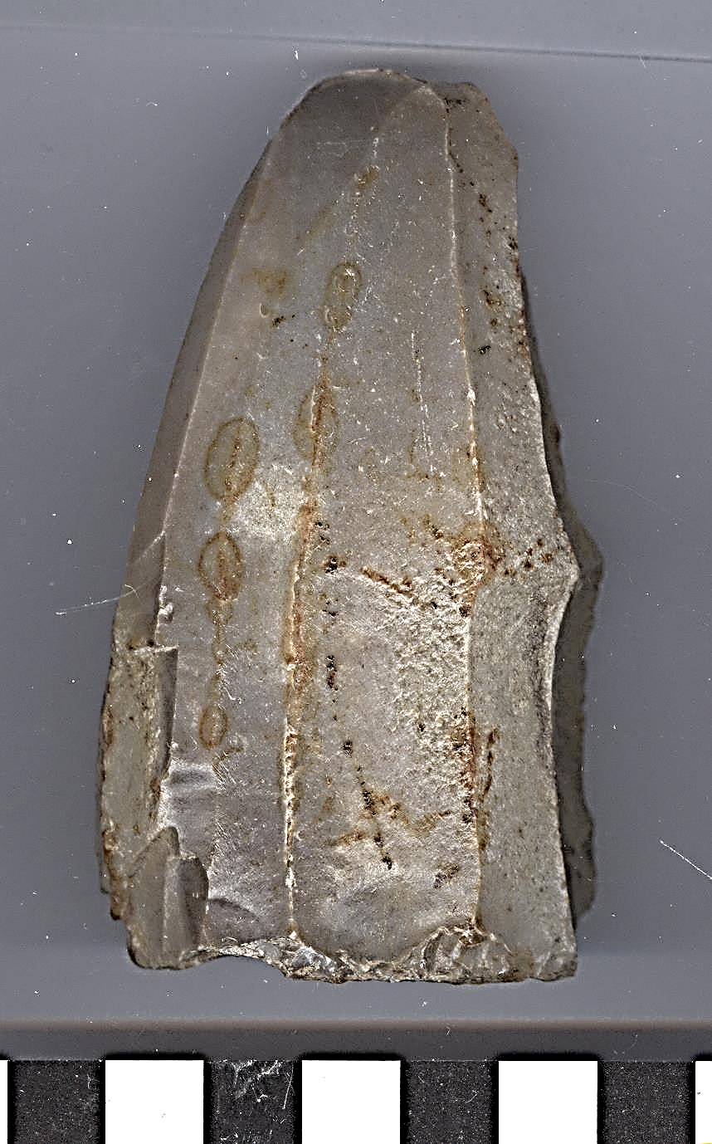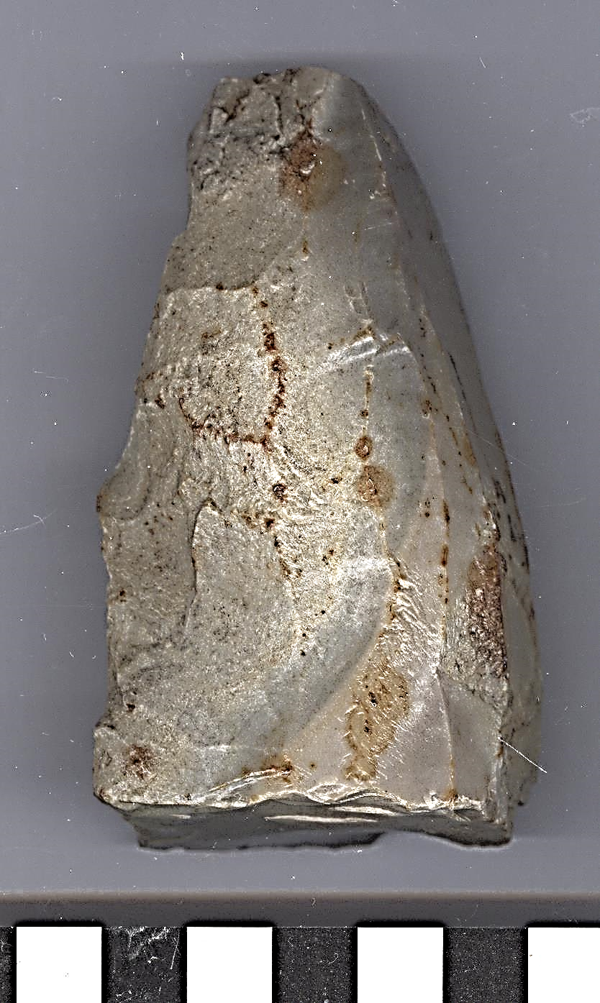

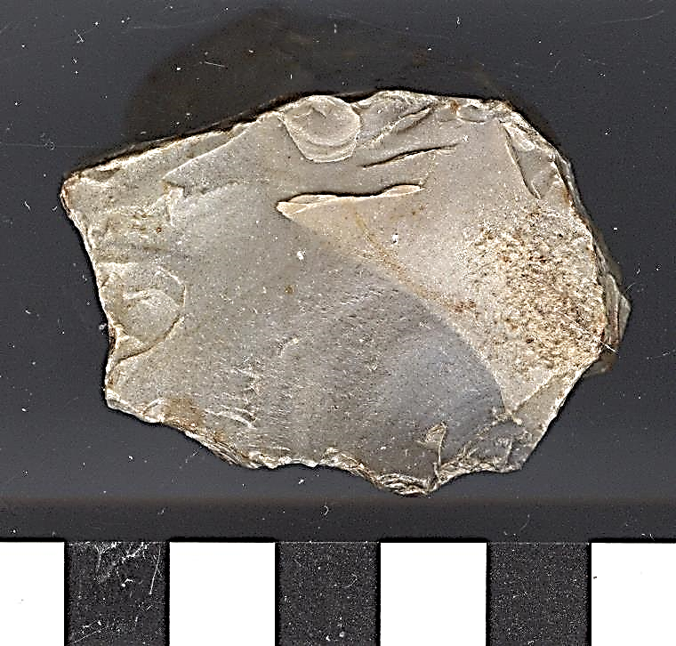 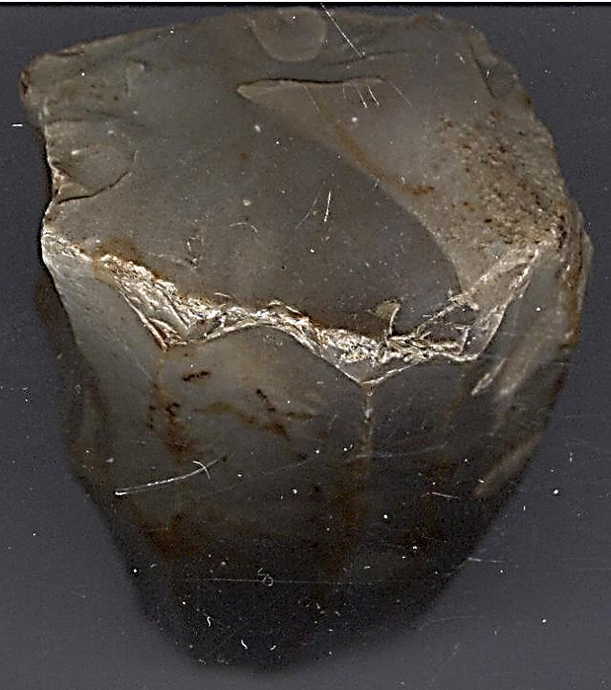

**Formal Label:** Le Grand Pressigny, France, Neolithic- Flint Core-3500 BP

**Accession Number: A 20**

**LC Classification:** GN776.22.F7

**Date or Time Horizon:** 3500 BP

**Geographical Area:** Le Grand Pressigny

**Map, GPS coordinates:**

**Medium:** Flint

**Dimensions: H 3.36 in (85.38 mm), T1 1.9 in 49.1 mm, T2 1.30 in. (32.92 mm)  
Weight:**

**Provenance: from an** old Belgian collection.

**Condition:** original.

**Discussion:** The Grand Pressigny is the eponymous name of a Neolithic flint industry known since 1863 for its blades, which are expertly flaked from a "butter pound" core of which this is an excellent example.

**References:**

## Alfred S. Barnes. 1947. The Production of Long Blades in Neolithic Times, American Anthropologist, New Series, 49(4) Part 1, 625-630.

Louboutin, C. 2011. Archeology of the Touraine. Éditions La Simarre

Mallet, Nicole. 1992. *Grand-Pressigny: ses relations avec la civilisation Saône-Rhône*. [Argenton-sur-Creuse?]: Amis du Musée de préhistoire du Grand-Pressigny. v.1. Texte -- v. 2. Planches.

Steenstrup, J. and John Lubbock. 1867. “On the Flint Implements Recently Discovered at Pressigny-le-Grand,” *Transactions of the Ethnological Society of London*, 5: 221-227.